

Executive Summary: SURVEY NAME
University Name
Date

SCHOOL LOGO HERE

Introduction
Our institution administered the INSERT SURVEY NAME which is part of the Satisfaction and Priorities Surveys (SPS) from Encoura+RNL.
The surveys which are included in the Satisfaction and Priorities Survey family are:
- Student Satisfaction Inventory™ (SSI) for traditional undergraduate students at four-year and two-year institutions;
- Adult Student Priorities Survey™ (ASPS) for students 25 years of age and older, primarily at
four-year institutions; the survey is appropriate for undergraduate and graduate level students;
- Priorities Survey for Online Learners™ (PSOL) for students in online learning programs;
Satisfaction assessments are a key indicator for the institution of the current student experience. The data from the assessments provide direction for our campus to make improvements in the areas that matter most to your students.
The family of Satisfaction and Priorities Surveys ask students to indicate both the level of importance they place on an item, as well as their level of satisfaction that the institution is meeting this expectation. The results provide a roadmap for next steps that the institution can and should take to respond to the issues that students have identified.

Data left on a shelf has no power; data actively used and discussed provides the opportunity to initiate significant change on campus.

As we review these data, it is important to keep in mind how the results will be shared on our campus. The greatest power of the data comes when the findings are shared, discussed, and analyzed by multiple constituencies on campus.
Populations we will want to share these results with include:

- President and campus leadership;
- Deans, and directors;
- Student life personnel;
- Admissions and financial aid personnel;
- Faculty;
- Staff, especially those with face-to-face interaction with students;
- Board of trustees;
- Student government leadership;
- General student population;
- Parents of students;
- Alumni; and
- Local community.

Our Administration
The INSERT SURVEY NAME was administered on our campus during the Fall/Spring of YEAR.
The survey was completed by NUMBER students. We had a response rate of RESPONSE RATE out of the NUMBER who were invited to complete the online survey.
>> This information comes from your SPS Online Administration site.
Demographic Overview
The students who completed the survey are representative of our overall population. This is an overview of the students reflected in this data set.
GENDER | Count | Percentage
Female
Male
Prefer not to respond
Transgender
Genderqueer
Additional gender category or Other

CLASS LEVEL | Count | Percentage
Freshmen
Sophomore
Junior
Senior
Graduate/Professional

It is important to track institutional choice because it has been documented that students who perceive themselves to be at their first choice institution tend to have higher satisfaction than students who perceive themselves to be at their second or third choice institution.
INSTITUTIONAL CHOICE | Count | Percentage
1st choice
2nd choice
3rd choice or lower

NOTE: You can add other relevant demographic responses as appropriate. For example, community colleges may want to highlight full-time/part-time class load distribution.
>> This information is from the Main Report, Demographic tab.

Our Strengths and Challenges
Matrix for Prioritizing Action:
This visual helps to conceptualize the results from our survey results.
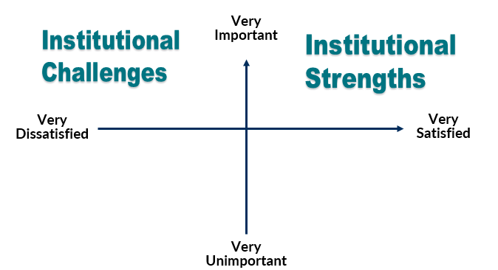
Strengths
Strengths are items with high importance and high satisfaction. These are specifically identified as items above the mid-point in importance (top half) and in the upper quartile (25 percent) of our satisfaction scores. The strengths are listed in descending order of importance.
INSERT YOUR LIST OF STRENGTHS, IN DESCENDING ORDER OF IMPORTANCE HERE

We will want to celebrate our strengths!
>> This information is from the Main Report, Strategic Planning Overview tab.

Challenges
Challenges are items with high importance and low satisfaction or a large performance gap. These are specifically identified as items above the mid-point in importance (top half) and in the lower quartile (25 percent) of your satisfaction scores or items above the mid-point in importance (top half) and in the top quartile (25 percent) of our performance gap scores. The performance gap score is likely the reason the item has been identified as a challenge. The challenges are listed in descending order of importance.
INSERT YOUR LIST OF CHALLENGES, IN DESCENDING ORDER OF IMPORTANCE HERE

We will need to respond to our challenges!
>> This information is from the Main Report, Strategic Planning Overview tab.

Summary Satisfaction and Re-Enrollment Scores
Students provide the responses to these last two items on the survey to indicate their overall levels of satisfaction and the likelihood that they would re-enroll here again if they had it to do over. The bar chart below reflects the percentage of students who indicated they were satisfied or very satisfied with their experience and the percentage that said they would probably or definitely re-enroll here again if they had it to do over.

Update the bar chart with your summary scores responses and your corresponding national data. You can also add in longitudinal data here as appropriate.
>> This information is from the Main Report, Summary Report tab. The scores are typically reflected with the combination of answers 6 and 7: satisfied/very satisfied and probably yes/definitely yes.

Items with a significant shift in satisfaction
Since our last administration, the following items have seen significant improvement in student satisfaction.

If you have surveyed your students more than once, insert a list here of items with positive differences, that are statistically significant (with at least one star) from the Item Report in the Year to Year Report. You can also choose to show the amount of improvement year over year. As appropriate, you may need to highlight items that had significant drops in satisfaction as well.
>> This information is from the Year to Year Report, Item Report tab, sorted by the difference column.
Additional Context on Assessing Student Satisfaction
Why is Satisfaction Surveying Important?
Studies have shown that student satisfaction is linked to key institutional metrics including higher individual student retention at both four-year and two-year institutions, higher institutional graduation rates, higher alumni giving at the institutional level and lower loan default rates. If you would like to learn more about these links, visit www.RuffaloNL.com/Assessment.

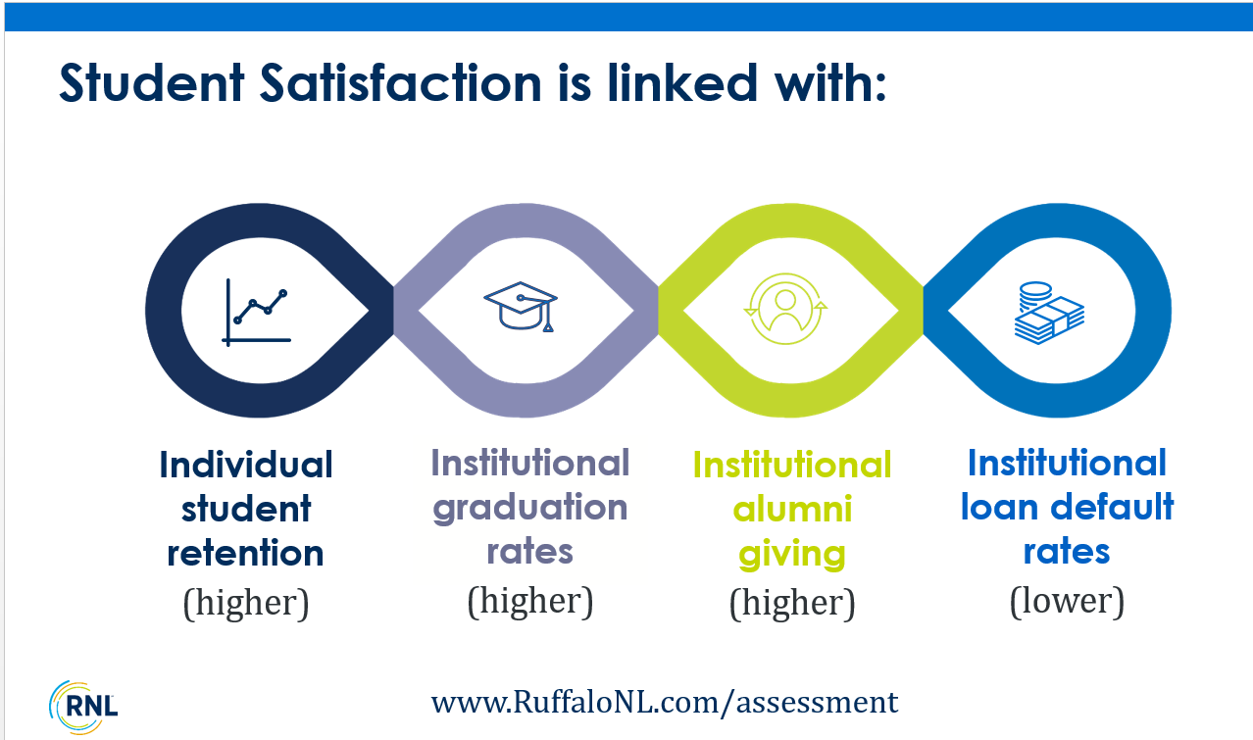

Reliability and Validity
The reliability and validity of these survey tools from are very strong. Additional information is available on the Website: www.RuffaloNL.com/SPSInterpretiveGuides

Systematic Assessment Cycle
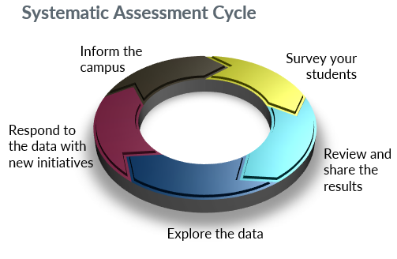
Assessing student satisfaction can be approached as a five-step cycle of activities:
- Survey our students. We will want to have a regular cycle for gathering student satisfaction data. Student satisfaction assessments are not once and done activities. Most institutions survey students once every other year in order to maintain a strong momentum with actively using the data and responding to it.
- Review and share the results. Communicating the results from our survey is critical to making changes at our institution. We will want to share the results widely with leadership, departments, faculty and students.
- Explore the data. Before we identify specific initiatives to improve the student experience, we will want to explore the data further by identifying key demographic variables to review in the reporting dashboard and by reviewing the qualitative comments. Another option is to explore the results on our campus by conducting focus groups and/or listening sessions to gather more qualitative feedback.
- Respond to the data with new initiatives. We can approach responses to our challenges in three primary ways:
- Changing perceptions through information and communication.
- Implementing quick and easy actions that resolve the issues.
- Planning for long-term, strategic adjustments in the delivery of the service.
- With responses two and three, it is still important to incorporate communication into the responses so that students are appropriately informed of any immediate resolution, or can be made aware of the issues that will require more time and resources.
- Inform the campus. We will want to be careful to not assume that students and the larger campus constituencies will automatically be aware of the improvements we have made. We will need to be intentional in our communication efforts to inform the campus that the survey results indicate a priority and we took this action in response. This follows the model of “You said this, we did that.” By informing the students of our activities, we are more likely to see satisfaction levels improve with our next survey administration.

Using our data in multiple ways

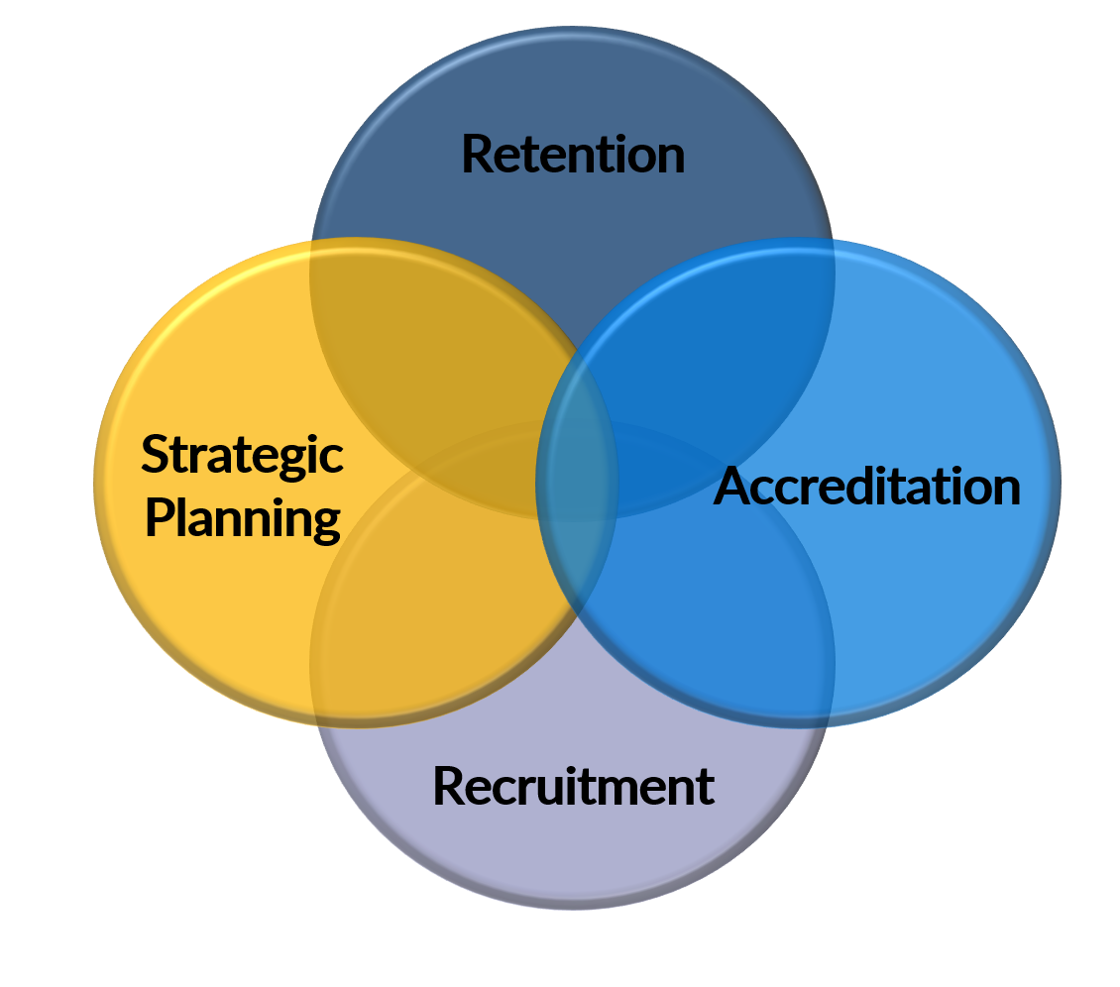
The data from the Satisfaction-Priorities Surveys can be utilized in multiple ways to inform our work on campus.
- Retention: These data will help us to understand where our students are satisfied for not satisfied, within the context of what matters to them which will help us to prioritize our student success and retention efforts. We will want to work on the areas that our students say have the biggest room for improvement (our Challenges). We can show our students that we care about them by responding to these top priority concerns. We will be able to re-recruit our students to stay enrolled at our college.
- Strategic Planning: These data provide the student voice for our strategic planning efforts. We can look specifically at areas of concern that we can’t fix immediately and include them in our longer term vision for our institution.
- Accreditation: Student satisfaction data are valuable for accreditation efforts. By surveying our students on a regular basis, we can track changes in the student satisfaction and reflect improvements in the student experience based on the actions we have taken. This will be well received by our regional accreditors. The individual items on the survey have been mapped to the criteria for each regional accreditor: www.RuffaloNL.com/accreditation
- Recruitment: We can use these data to recruit new students to our institution by focusing on our student-identified strengths. By highlighting the positives, the areas that our students care about where they are also very satisfied (our Strengths), we can recruit new students to the institution that are going to place a high value on areas where we are already performing well. Our admissions and marketing teams will want to help us celebrate the good news from these results!
Additionally, we can make the most of our investment by targeting initiatives to be sure we have satisfied graduating students who will be willing to give back to the institution as engaged alumni. If we have served them well throughout their educational experience, and if we have kept them enrolled and they are satisfied at they are completing their degree, we are more likely to have a positive impact on our advancement and alumni giving efforts.

Institutional Next Steps
In this section, you can highlight any next steps that have been identified:
- Presentations of the data to various campus audiences
- Planned focus groups and listening sessions
- Committee meetings to identify next steps
- Additional data analysis and when it will take place
- Etc.

You can also include the contact information for the individual or the office managing the data and/or how to get access to the full results.
You can also consider including an appendix with the Item Report vs. the National Comparison, or the Item Percentage Report vs. the National Comparison (available in the Main Report).
You may also want to indicate that there are additional resources for using and interpreting the results on the Website: www.RuffaloNL.com/SPSClientResources.

