<SCHOOL LOGO>

Summary of Noel-Levitz Survey Results
The Student Satisfaction InventoryTM (SSI) measures student satisfaction and priorities, showing how satisfied students are with various aspects of the College and what issues are most important to them.
The Institutional Priorities SurveyTM (IPS) measures faculty and staff perceptions of the student experience.
Administration: March 2014
Response rates
Students: 1,168 responses (16% response rate)
Faculty/Staff: 551 responses (56% response rate)
Overall Impressions
Students: Overall, students expressed high levels of satisfaction with nearly all aspects of the College.
Faculty/Staff: Although faculty and staff were mostly positive, they expressed a somewhat more negative view of students’ experience at College.
Noel-Levitz Scales
Noel-Levitz combines several different groupings of survey items to form 12 composite scales:
Academic Advising (and Counseling) Effectiveness: assesses the comprehensiveness of College’s academic advising program. Academic advisors (and counselors) are evaluated on the basis of their knowledge, competence, and personal concern for student success, as well as on their approachability. | Recruitment (or Admissions) and Financial Aid Effectiveness: assesses College’s ability to enroll students in an effective manner. This scale covers issues such as competence and knowledge of admissions counselors, as well as the effectiveness and availability of financial aid programs.
Academic Services: assesses services students utilize to achieve their academic goals. These services include the library, computer labs, tutoring and study areas. | Registration Effectiveness: assesses issues associated with registration and billing. This scale also measures College’s commitment to making this process as smooth and effective as possible.
Campus Climate: assesses the extent to which College provides experiences that promote a sense of campus pride and feelings of belonging. This scale also assesses the effectiveness of College’s channels of communication for students. | Responsiveness to Diverse Populations: assesses College’s commitment to specific groups of students, e.g., under-represented populations; students with disabilities; and older, returning learners.
Campus Support Services: assesses the quality of College’s support programs and services which students utilize to make their educational experiences more meaningful and productive. | Safety and Security: assesses College’s responsiveness to students’ personal safety and security on campus. This scale measures the effectiveness of both security personnel and campus facilities.
Concern for the Individual: assesses College’s commitment to treating each student as an individual. Those groups who frequently deal with students on a personal level (e.g., faculty, advisors, etc.) are included in this assessment. | Service Excellence: assesses the perceived attitude of staff, especially front-line staff, toward students. This scale pinpoints the areas of the campus where quality service and personal concern for students are rated most and least favorably.
Instructional Effectiveness: assesses College’s students’ academic experiences, the curriculum, and the campus’s overriding commitment to academic excellence. This comprehensive scale covers areas such as the effectiveness of College’s faculty in and out of the classroom, content of the courses, and sufficient course offerings. | Student Centeredness: assesses College’s efforts to convey to students that they are important to the institution. This scale measures the extent to which students feel welcome and valued.

Scales Rated in Terms of Importance:
Both students and faculty/staff gave Instructional Effectiveness high importance ratings.
Faculty/staff placed a higher value on Concern for the Individual and Safety and Security than did students.
Students placed a higher value on Registration Effectiveness and Academic Advising/Counseling than did campus personnel.
Students | Faculty/Staff
Instructional Effectiveness | Concern for the Individual
Academic Advising/Counseling | Instructional Effectiveness
Registration Effectiveness | Safety and Security
Admissions and Financial Aid | Academic Advising/Counseling
Concern for the Individual | Campus Climate
Safety and Security | Admissions and Financial Aid
Academic Services | Student Centeredness
Service Excellence | Service Excellence
Campus Climate | Academic Services
Student Centeredness | Registration Effectiveness
Campus Support Services | Campus Support Services

Noel-Levitz Definitions

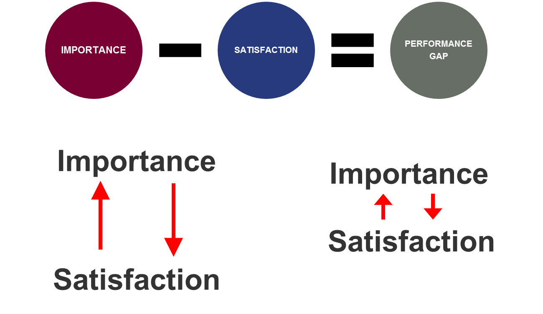
Strengths
Strengths are items rated with high importance and high satisfaction.

Challenges
Challenges are items rated with high importance and lower satisfaction or that have a performance gap.

Performance Gap:
A performance gap is the importance score minus the satisfaction score for each item. The larger the performance gap, the greater the discrepancy between what students expect and their level of satisfaction with the current situation. The smaller the performance gap, the better the institution is doing at meeting student expectations.

Strengths: Strengths are survey items ranked high in terms of both importance and satisfaction. The highlighted items indicate areas of agreement between students and faculty/staff.

Students | Faculty/Staff
My academic advisor is knowledgeable about my program requirements. | Security staff respond quickly in emergencies.
I am able to experience intellectual growth here. | The campus is safe and secure for all students.
Nearly all of the faculty are knowledgeable in their fields. | Nearly all of the faculty are knowledgeable in their fields.
The campus is safe and secure for all students. | Faculty care about students as individuals.
My academic advisor is approachable. | This institution has a good reputation within the community.
There is a good variety of courses provided on this campus. | Students are able to experience intellectual growth here.
Faculty are usually available after class and during office hours. | Program requirements are clear and reasonable.
There are convenient ways of paying my school bill. | There is a good variety of courses provided on this campus.
Students are made to feel welcome on this campus. | Counseling staff care about students as individuals.
 | The campus staff are caring and helpful.

Challenges: Challenges are survey items with performance gaps between importance and satisfaction ratings. The highlighted items indicate areas of agreement between students and faculty/staff.

Students | Faculty/Staff
The quality of instruction I receive in most of my classes is excellent. | Academic advisors are knowledgeable about program requirements.
I am able to register for classes I need with few conflicts. | The personnel involved in registration are helpful.
Faculty provide timely feedback about student progress in a course. | Academic advisors are approachable.
Classes are scheduled at times that are convenient for me. | Students seldom get the "run-around" when seeking information on this campus.
Adequate financial aid is available for most students. | Policies and procedures regarding registration and course selection are clear and well-publicized.
Financial aid counselors are helpful. | Academic advisors are knowledgeable about the transfer requirements of other schools.
The quality of instruction in the vocational/technical programs is excellent. | Financial aid counselors are helpful.
This school does whatever it can to help me reach my educational goals. | The equipment in the lab facilities is kept up to date.
Faculty are understanding of students' unique life circumstances.
Financial aid awards are announced to students in time to be helpful in college planning.
I seldom get the "run-around" when seeking information on this campus.
The personnel involved in registration are helpful.
Students are notified early in the term if they are doing poorly in a class.
My academic advisor is knowledgeable about the transfer requirements of other schools.
My academic advisor is concerned about my success as an individual.
The college shows concern for students as individuals.
The amount of student parking space on campus is adequate.

Student Satisfaction (Items Ranked Below National Community Colleges)

The amount of student parking space on campus is adequate.

Faculty/Staff Perception of Student Satisfaction (Items Ranked Below National Community Colleges)

The career services office provides students with the help they need to get a job.
Academic advisors are approachable.
Students are able to register for classes they need with few conflicts.
The amount of student parking space on campus is adequate.
Students seldom get the "run-around" when seeking information on this campus.
Institution's commitment to under-represented populations.
Policies and procedures regarding registration and course selection are clear and well-publicized.
Students are made to feel welcome on this campus.
Financial aid awards are announced to students in time to be helpful in college planning.
Academic advisors are knowledgeable about program requirements.
Class change (drop/add) policies are reasonable.
The assessment and course placement procedures are reasonable.
The personnel involved in registration are helpful.
Financial aid counselors are helpful.
The equipment in the lab facilities is kept up to date.
On the whole, the campus is well-maintained.
Computer labs are adequate and accessible.

Student Satisfaction Summary Items

So far, how has your college experience met your expectations? (59% positive compared to 52% nationally)

Rate your overall satisfaction with your experience here thus far. (81% satisfaction compared to 77% nationally)

All in all, if you had to do it over, would you enroll here again? (84% positive compared to 79% nationally)

Next Steps

Professional Development Day: This year’s Professional Development Day will be devoted to an in-depth look at our Noel-Levitz data.

Professional Development Training: We are currently working to design professional development training sessions that are guided by Noel-Levitz survey results.

Survey Schedule: We plan to implement Noel-Levitz surveys every two years as part of our College-wide continuous improvement plan.

